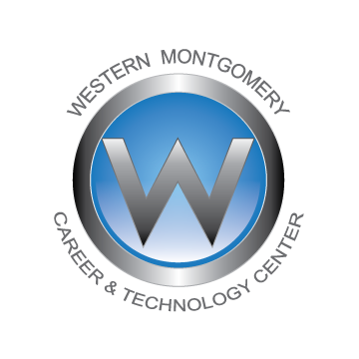

Dear Student/Parent/Guardian:

Your daughter/son will have many opportunities as a senior/junior in the PLTW Biomedical Sciences Program during the 2024-2025 school year. The Biomedical Sciences Program is designed as a rigorous program of study for the motivated student.

Students will explore the concepts of medical terminology, human medicine and are introduced to topics such as physiology, genetics, microbiology, human body systems, and the variety of interventions involved in the prevention, diagnosis, and treatment of disease, exploration of the various roles of health care providers and basic clinical skills.

Opportunities to observe healthcare delivery in clinical settings is generally provided. The students will be required to wear uniforms in the classroom and for all site visits. The students are required to wear a dark gray scrub top and pants, black shoes/sneakers (leather/leather like closed toed, no holes). We will discuss the acceptable type of black shoes during the first week of school. Students are required to purchase one or two sets of dark GRAY scrubs (Walmart, Uniform Outlet, WMCTC website) and be in uniform by September 9, 2024. They may purchase a uniform through WMCTC. The link can be found on the Western Montgomery Career and Technology Center website.

If clinical rotations are approved, students will be required to have a copy of recently updated immunization record, a 2-step PPD (tuberculosis screening), receive an influenza vaccination, possible COVID 19 vaccination (unless you already had the vaccination) and complete a criminal background check (free online-must check volunteer). A urine drug screening may be required at a later date through the Hospital (Phoenixville or Pottstown) at no cost to the student. These requirements are dependent upon the policy of the clinical setting we may be utilizing and are subject to change. Paperwork will be provided with instructions for completion at the beginning of the 2024/2025 school year pending clinical approval.

If you have any questions, please call me at 610-489-7272, ext. 115 after August 20th or email me at lcassidy-lawler@westerncenter.org. The first day of class is August 26, 2024. I am looking forward to working with your student in the coming school year.

Your success at WMCTC is our success.

Sincerely,

Lisa Cassidy Lawler, RN, BSN, M.Ed

PLTW Biomedical Sciences Program Instructor